 | MINISTRY OF EDUCATION AND TRAINING

FPT UNIVERSITY

CAPSTONE PROJECT DOCUMENT
PROPELLER LED

Fast5
Group Member | Nguyễn Thanh Tùng | SE01960
Group Member | Đinh Quang Hải | SE02354
Group Member | Đỗ Văn Ban | 01870
Group Member | Đinh Xuân Bách | 60343
Group Member | Nguyễn Thế Long | SE02241
Supervisor | Mr. Phan Duy Hùng
Project Code | pLED

Hanoi, April 10, 2014

Content

Content 2
ACKNOWLEDGEMENTS 5
DICTIONARY 6
CHAPTER 1: INTRODUCTION 9
1. Video Propeller Led 9
2. Idea 9
3. Existed Product 10
3.1 Bob Blick Propeller Clock – The first project^{[1]} 10
3.2 AVClock^{[2]} 14
4. SCOPE 17
CHAPTER 2 : PROJECT MANAGEMENT 18
1. PURPOSE 18
2. PROJECT OVERVIEW 18
2.1 Project Description 18
2.2 Scope 18
2.3 Standard Objectives 19
2.4 Milestone and Deliverables 19
3. PROJECT ORGANIZATION 19
3.1 Software Process Model 19
3.2 Project lifecycle 19
3.3 Roles and Responsibilities 20
4. TOOL AND INFRASTRUCTURE 21
4.1 Hardware 21
4.2 Software 21
5. SCHEDULE 21
5.1 Detailed Schedule 21
5.2 Meeting Schedule 23
5.3 Effort Estimation 24
6. RISK MANAGEMENT 24
CHAPTER 3 : SOFTWARE REQUIREMENT 25
1. USER REQUIREMENT SPECIFICATION 25
1.1 Purpose 25
1.2 Overall Description 25
1.3 Functional requirement 26
1.4 Non-functional requirement 26
2. SYSTEM REQUIREMENT SPECIFICATION 26
2.1 Purpose 26
2.2 System purpose 26
2.3 Scope 26
2.4 Overall Description 27
2.5 Functional specification 28
2.6 Non-functional specification 32
CHAPTER 4 : PRODUCT DESIGN 33
1. SOFTWARE DESIGN 33
1.1 ARCHITECTURE DESIGN 33
1.2 DETAILED DESIGN 33
1.3 DATA-STRUCTURE DESIGN 42
2. HARDWARE DESIGN 43
2.1 CIRCUIT BOARD 43
2.2 MOTOR AND BASE 46
CHAPTER 5 : TEST 51
1. INTRODUCTION 51
1.1 Purposes 51
1.2 System Overview 51
2. TEST PLAN 51
2.1 Scope of Testing 51
2.2 Plan of test 51
2.3 Requirements for Testing 52
2.4 Test Strategies 52
3. TEST CASES 57
3.1 Circuit board connection 57
3.2 Base's stability 63
4. TEST LOGS 64
4.1 Defect Logs 64
4.2 Test Reports 65
CHAPTER 6 : USER’S GUIDE 66
1. USER’S GUIDE 66
1.1 Purpose 66
1.2 Function’s Description 66
1.3 Detailed Guidelines 66
LESSON LEARNT 67
REFERENCE 67

Content of Figures
Figure 1: Bob Blick Propeller clock 10
Figure 2: Schematic of Bob Blick’s product 11
Figure 3: Motor design of BobBlick 12
Figure 4: AVClock – Power source 12
Figure 5: AVClock - External Interrupt 13
Figure 6: AVClock - I2C Communication 13
Figure 7: AVClock - Remote receiver 14
Figure 8: AVClock - Micro Controller 14
Figure 9: IID model 16

ACKNOWLEDGEMENTS

During the implementation of this project, we have received overwhelming support from a number of people, to whom we would like to express our great appreciation. Without them, this project would have been done with much more obstacles than it was.
First and foremost, we would like to show our thankfulness to our supervisor of this project – Mr. Phan Duy Hùng. He has given us not only many valuable advices but also enthusiastic inspirations that helped raising our team members’ spirit.
We would like to offer our special thanks to Đinh Xuân Bách, for his very big support so we can have a wide and convenient room to work.
Last but not least, we are thankful to our families and our friends for their constant encouragement and support throughout this project.

DICTIONARY
- LED: Light emitting diodes.
- POV: Persistence of Vision: is the phenomenon of the eye by which an afterimage is thought to persist for approximately one twenty-fifth of a second on the retina, and believed to be explanation for motion perception, however it only explains why the black spaces that come between each "real" movie frame are not perceived. The true reason for motion perception is the phi phenomenon.
- Phi phenomenon: the optical illusion of perceiving continuous motion between separate objects viewed rapidly in succession.
- pLED: Project code, Abbreviation for propeller display LEDs.
- Propeller LED: This is a linear array of light emitting diodes, rotating at a high angular velocity to generate a circular motion. By synchronizing these light emitting diodes to exploit concepts of persistence of vision, the product can create an LED screen from a straight array LEDs.
- Perfboard: A material for prototyping electronic circuits also called (DOT PCB).
- RPM: Rounds per minute
- RF: Radio Frequency
- Hall sensor: A component that can catch a magnetic signal.
- Shift Register: is a cascade of flip flops, sharing the same clock, in which the output of each flip-flop is connected to the "data" input of the next flip-flop in the chain, resulting in a circuit that shifts by one position the "bit array" stored in it, shifting in the data present at its input and shifting out the last bit in the array, at each transition of the clock input.
- ICSP: In Circuit Serial Programming
- RS-232: A standard for serial communication transmission of data.
- I²C: Inter-Integrated Circuit: used for attaching low-speed peripherals to a motherboard, embedded system, cellphone, or other digital electronic devices.
- Development kit: Include testing board, board design software, emulation software, firmware IDE.
- FU: FPT University.
- PM: Project Manager.
- QA: Quality Assurance
- STD: System Test Document.
- SDD: System Design Description.
- SRS: System Requirements Specifications .
- RMP: Risk Management Plan.
- PMP: Project Management Plan.
- SUM: Software User’s Manual.
- Interrupt: In systems programming, an interrupt is a signal to the processor emitted by hardware or software indicating an event that needs immediate attention. An interrupt alerts the processor to a high-priority condition requiring the interruption of the current code the processor is executing (the current thread). The processor responds by suspending its current activities, saving its state, and executing a small program called an interrupt handler (or interrupt service routine, ISR) to deal with the event. This interruption is temporary, and after the interrupt handler finishes, the processor resumes execution of the previous thread.
- Hardware interrupt: is an electronic alerting signal sent to the processor from an external device, either a part of the computer itself such as a disk controller or an external peripheral. Unlike the software type (below), hardware interrupts are asynchronous and can occur in the middle of instruction execution, requiring additional care in programming.
- Software interrupt: is caused either by an exceptional condition in the processor itself, or a special instruction in the instruction set which causes an interrupt when it is executed. The former is often called a trap or exception and is used for errors or events occurring during program execution that are exceptional enough that they cannot be handled within the program itself. Software interrupt instructions function similarly to subroutine calls and are used for a variety of purposes, such as to request services from low level system software such as device drivers.
- NODE: One rotation cycle of propeller is divided by 60 position. Each position is called NODE.
- DC: Direct Current.
- Commutator: is the moving part of a rotary electrical switch in certain types of electric motors or electrical generators that periodically reverses the current direction between the rotor and the external circuit.

CHAPTER 1: INTRODUCTION

Video Propeller Led
Following is a short video of the completed product. It is will illustrate how does the propeller look like and we can imagine how does it works easier.
https://www.youtube.com/watch?v=_rqVn6ZLX_Q
or: http://goo.gl/iiIzZw

Idea
Propeller clocks are nothing new to anyone who has been into electronics for a while. They use an idea called POV, Persistence of Vision, which means that if something appears in the same spot consistently, at least 24 times per second, our brains think that it's permanently there when it really is not. TV's and Monitors use this method of display, so it's not as uncommon as you might think.
After research some forums and existed project but there is no public source and tutorial about multicolor propeller. We decided to build a 7-color propeller LED on our own to satisfy our curiosity and also as our capstone project.

Existed Product

Bob Blick Propeller Clock – The first project[1]
This is the first product of the propeller clock idea. After that, many common products have been recreate and improve not only in design but also in feature.
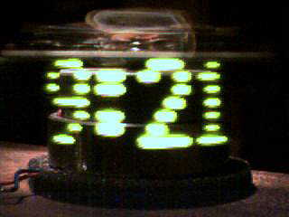

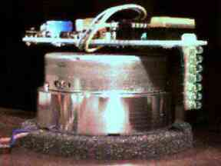
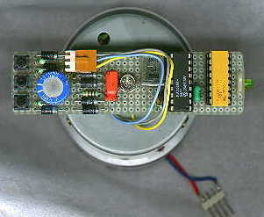

Figure 1: Bob Blick Propeller clock
The Propeller, a mechanically scanned LED clock by Bob Blick.
The clock is on a spinning piece of perfboard, but it must get power. They thought of many ways to do this, including using two motors(motor one has its shaft fixed to a base, and motor two spins the body of motor one, generating electricity), making a rotary transformer, or using slip rings.
They decided to do it another way, taking power from the spinning armature of a plain DC motor. In order to run the wires out of the motor, they removed the bearing from one end of the motor, leaving a big hole.

There are three terminals inside most small DC motors, and it acts a lot like three-phase alternating current, so it must be rectified back to DC. A nice side effect of this is that the position of the motor can be detected by taking one of the phases straight into the microprocessor.
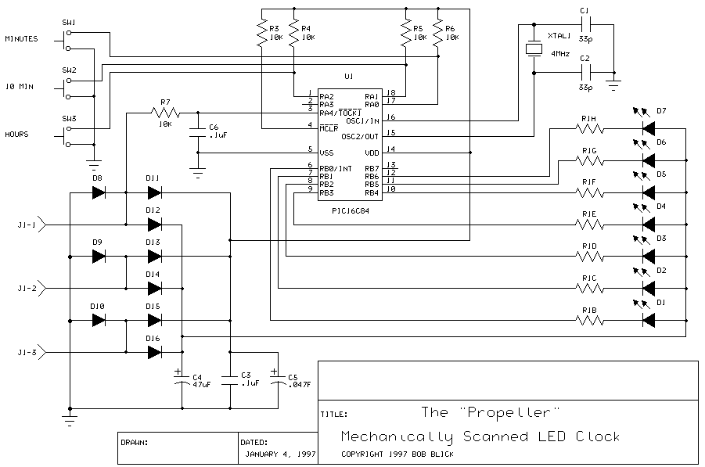
Figure 2: Schematic of Bob Blick’s product
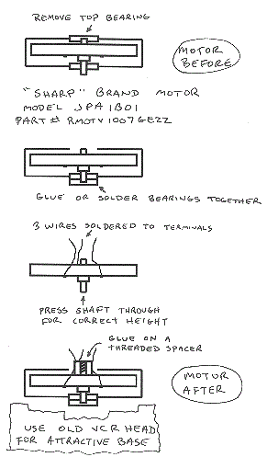
Figure 3: Motor design of BobBlick

AVClock^{[2]}
Schematic Design:
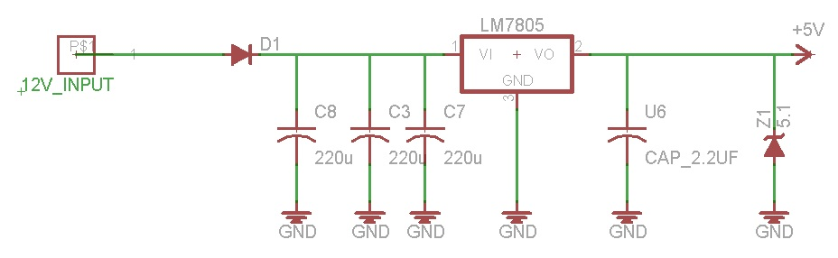
Figure 4: AVClock – Power source
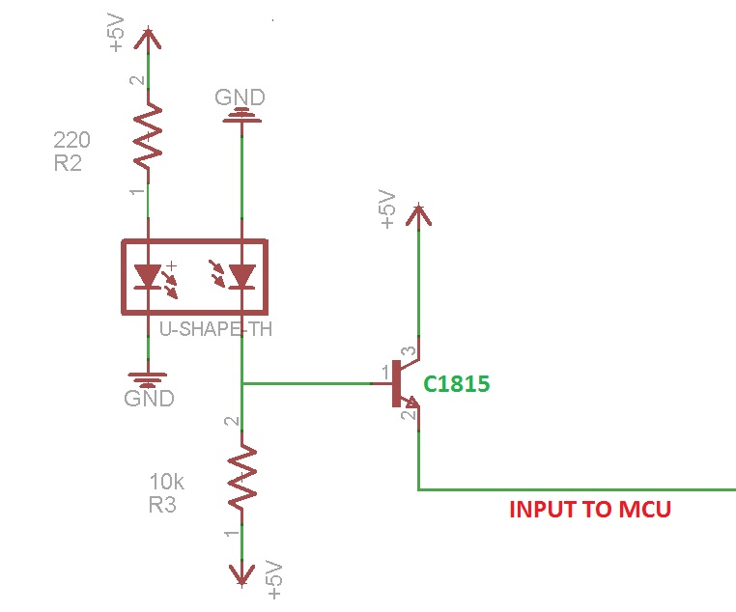
Figure 5: AVClock - External Interrupt
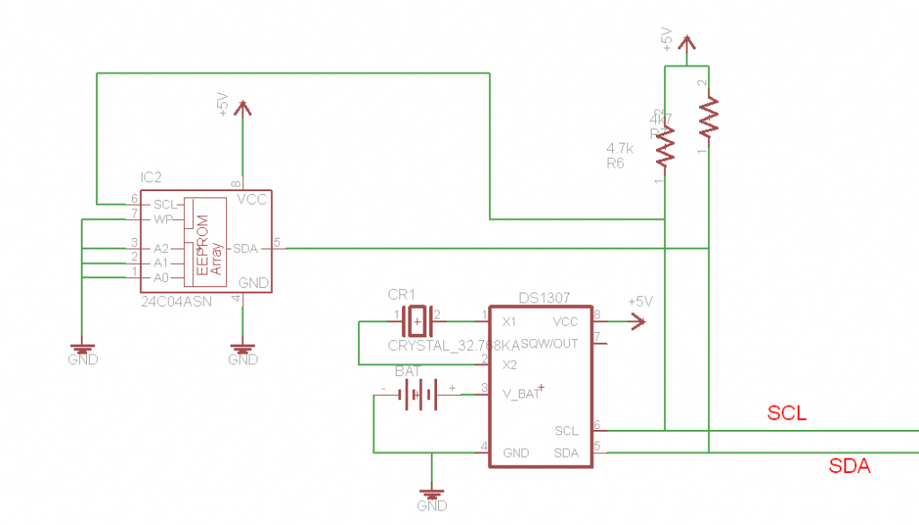
Figure 6: AVClock - I2C Communication
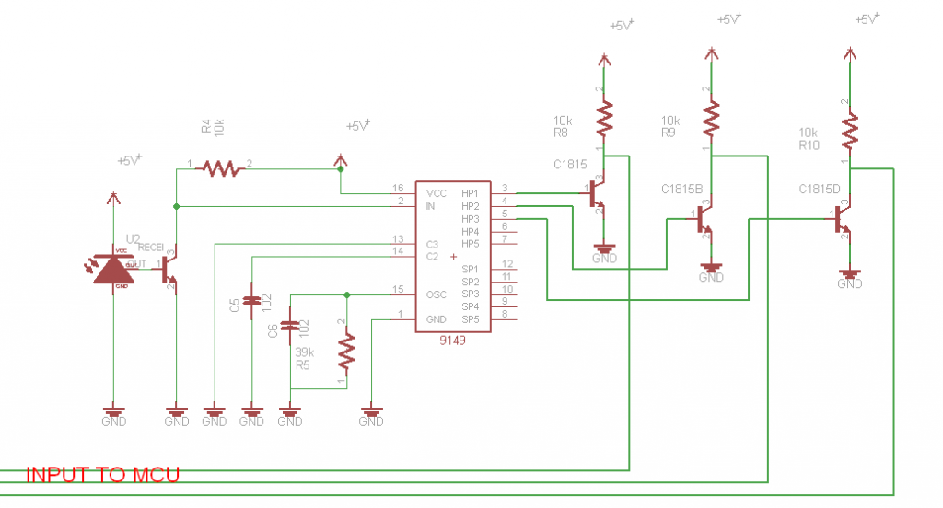
Figure 7: AVClock - Remote receiver
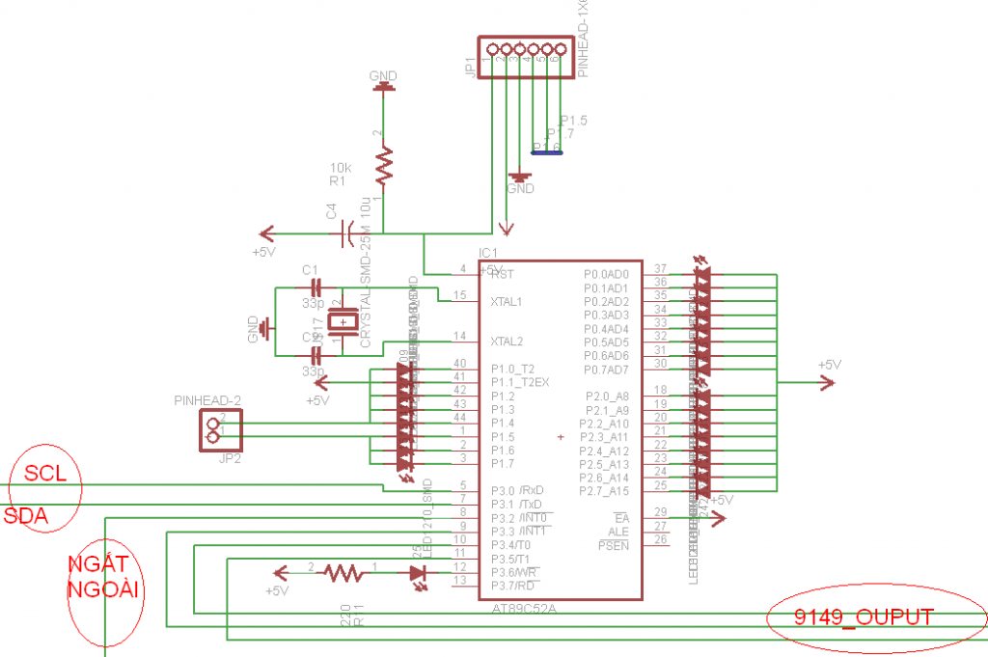
Figure 8: AVClock - Micro Controller

Final Product:
https://www.youtube.com/watch?v=yRS3Nvinm_I
Features:
- Display using single color LED but in high resolution (24 LEDs)
- Display Text, Clock, Animation
- Store real time
- Use infrared signal as remote system

Scope
The Project’s purpose is researching and developing the Propeller LED that has following properties:
- Have 4 modes of display
- Run stable in hours
- Display real time exactly
- Store time and need only one time setup
- Remote by RF transmitter

CHAPTER 2: PROJECT MANAGEMENT

System process
Project’s development process base on iterative and incremental development (IID).
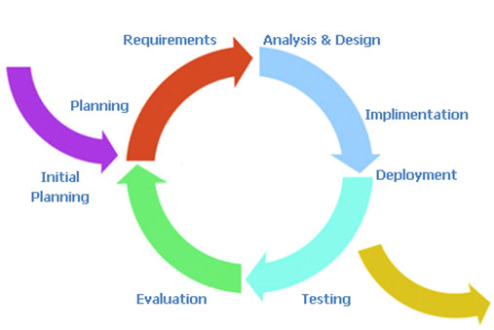
Figure 9: IID model

- IID provides regular feedback by breaking the project into iterations that are generally one to four weeks in length. The output of each iteration is working software with its necessary hardware or improvement on Schematic and Circuit board.
- The team estimates, plans and organizes work into iteration-sized chunks. The schedule feedback loop provides data that the team is on or off track by monitoring its ability to complete each iteration as planned.
- Requirements are the broken into smaller demonstrable units called stories. They are the estimate-able, testable, and deliverable units. They are small enough so can be completed within a single iteration.

Milestone
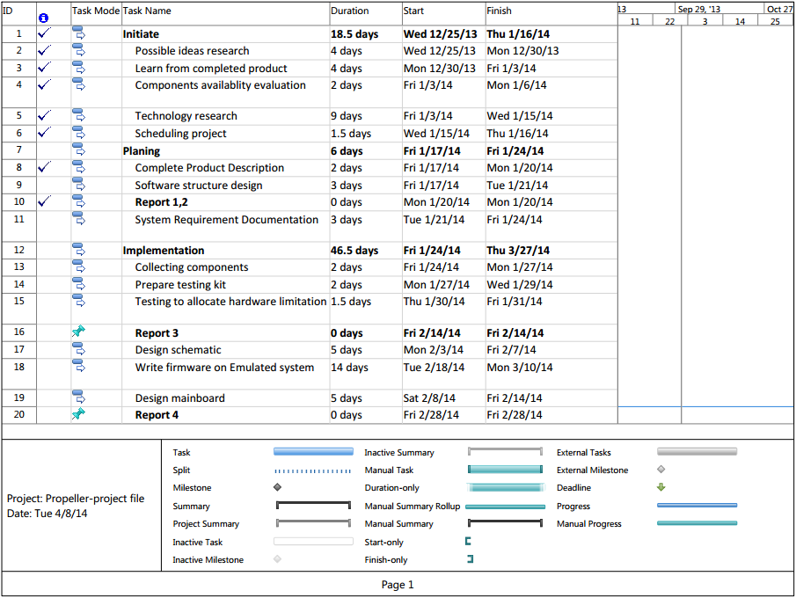
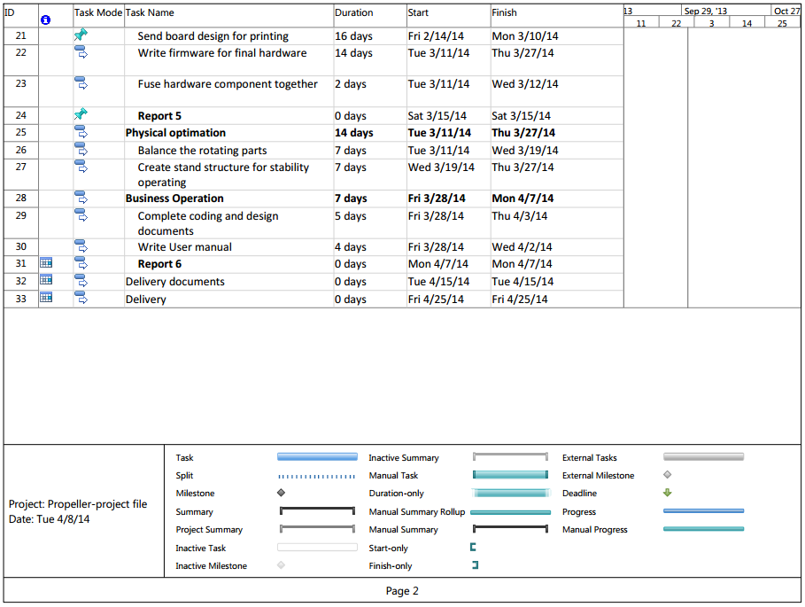

Roles and responsibilities
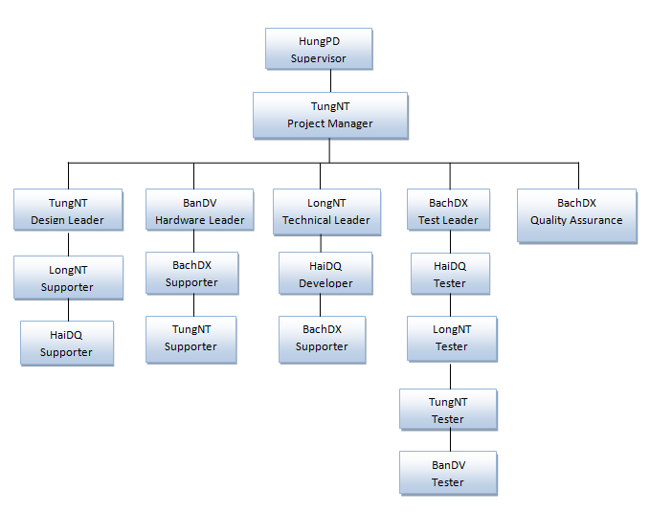
Figure 1.3: Team Roles

Full Name | Short Name | Phone | Email | Title
Phan Duy Hung | HungPD | 0975 597 339 | hungpd@fpt.edu.vn | Lecturer
Nguyen Thanh Tung | TungNT | 0973 634 694 | tungntse01960@fpt.edu.vn | Student
Do Van Ban | BanDV | 01697 107 655 | bandv01870@fpt.edu.vn | Student
Nguyen The Long | LongNT | 0913 048 672 | longntse02241@fpt.edu.vn | Student
Dinh Xuan Bach | BachDX | 0985 866 690 | bachdx60343@fpt.edu.vn | Student
Dinh Quang Hai | HaiDQ | 0168 782 8721 | haidqse02354@fpt.edu.vn | Student
Table 2.1: Contact’s information
Process | Procedures | Responsibilities
Project Management | Project Planning | 1. Prepares WBS:  + Understands project scope, project context. Identifies project lifecycle  + Prepares WBS  2. Estimates size of each work component in a measure suitable for the project, then gets it reviewed  3. Prepares schedule:  + Defines detail activities with timelines (Gantt Chart)  + Assigns the activities to project members  4. Prepares Project Management Plan (PMP)
Project Management | Project Executing | 1. Conducts the meeting with team members.  2. Reviews timesheet and record actual resource utilization.  3. Modifies or Updates project plan  If there are not any significant change on the plan we can modify it (without change request), if project have any major change, we must go back to Planning Project activities to update it.
Project Management | Project Monitor and Control | 1. Monitor project against plan:  1.1. Monitor project parameters:  + progress against schedule  + resources provided and used  + the attributes of work products and tasks  + knowledge and skill of project team  1.2. Document the significant deviations in the project planning parameters  2. Project Control:  + Analyze issues
Project Management | Project Closure | 1. Prepare the evidence (work products) to demonstrate that phase had got its objectives  2. The PM prepares the Project Final Report.  3. Select and document lesson learn and best practices  4. Prepare project close presentation material  5. The PM ensures the project end backups are taken.
Risk Management | Identify, analyze risks and create avoidance plan | 1. The PM and senior project team members meet to identify and analyze risks. The identified risks are documented  2. For each risk identified, agrees with the team on the probability and impact. Have plan to avoid risk.  3. Assigns members to performs the action according to mitigation/ contingency plan.
Configuration Management | Baseline | Create repository on code.google.com and grant permission to project’s member

Table 2.2: PM’s reponsibilities

Procedures |  | Responsibilities
Low Level Design |  | Design propeller’s display
Coding & Unit Testing |  | 1. Using the Unit Specifications document & the coding guidelines, the designated developer writes/ modifies the code for the assigned unit. The developer may also need to refer to earlier documents, such as SRS.  2. Readies the code for execution. Typically, this involves compiling the unit code. If decided by the PM, the code is reviewed before unit testing. Typically, this is done for critical units. If a review is performed, review comments are incorporated in the code, and this is verified  3. Updates the Requirement traceability matrix  4. Tests the unit using white-box unit test cases. Defects are logged in the defect log. The unit is debugged by the developer and the testing repeated till the unit is tested OK
Table 2.3: Developer’s responsibilities

Procedures |  |  | Responsibilities
High Level Design |  |  | 1. Prepares the Integration and System test case.  2. Update Requirement Traceability Matrix
Low Level Design |  |  | Prepares black box component test cases
Integration, System Testing |  |  | 1. Performs Integration test as per test plan and integration test cases  2. After Integration test, performs the system test as per test plan / system test cases
 |  |  | Table 2.3: Tester’s responsibilities
Process | Procedures |  | Responsibilities
Project Management | Project Planning |  | 1. Assist in project planning activities  + Life cycle selection  + Establishing the project’s defined process  + Setting quality goals and other objectives  + Understanding and usage of templates, forms, guidelines and checklists  + Identifying process training needs (as applicable)  + Getting information (like historical data, best practices, lessons learnt from similar projects, risks etc.) useful for project planning
Project Management | Project Executing |  | Assist in project execution activities  + Re-planning  + Facilitating team in understanding templates/forms  + Timely highlighting of process related potential issues (Formal)  + Participating in weekly or important meetings
Project Management | Project Closure |  | Assist in project closure activities  + Providing projects experiences
Table 2.5: QA’s responsibilities

Risk analysis and management

No | Risk | Analyze | Avoidance
HARDWARE
1 | Speed of motor is unstable | Power consumption of circuit board is inconstant | Separate power source of motor and circuit board
2 | Base has strong vibration | Motor run at high speed creates vibration | Increase the weight of the base to restrict the vibration
3 | Electric transmission is glimmering | Use carbon brush can make the current unstable because after run for a long time the brush is corrosive | Use rolling-element bearing to transmit the current
4 | Propeller is imbalance | The distribution of components on the circuit board is not proportional | Attach some heavy components to the circuit board to balance it
5 | Operation of IC is unstable | Some ICs are made in china, so the quality is not guaranteed | Test ICs carefully before use
6 | High speed of propeller | Some components can fly out | Use glue to fix components steady attach to the board
7 | Broken motor | Motor can be blown out after run for a long time | Make backup motors
SOFTWARE
8 | Micro chip is not fast enough | The program need faster chip to execute more command in a unit of time | Optimize code using better algorism. Modify CCSC’s library to reduce the number of command
9 | The amount of RAM is small | RAM is not enough to store all necessary data | Create algorism to locate data in ROM
10 | I2C communication’s speed is low | Each time read data from Real Time Clock, displaying LEDs get flicker | Only read time data after couples minutes
Table 2.6: Risk Management

Configuration Management

5.1 Project structure (SVN)
Repository |  |  |  | Guidelines
Branches |  |  |  | Baselines
Tags |  |  |  | Product release tranfer to customer
Trunks | 01. Pre-Sales | 011. SOW & Proposal |  | Proposal docs
Trunks | 01. Pre-Sales | 012. Contract |  | Project Contracts
Trunks | 02. Project Management | 021. Initiation |  | Initiation Note, Project charter
Trunks | 02. Project Management | 022. Estimation |  | Project Estimation Sheet
Trunks | 02. Project Management | 023. Project Plan |  | Master plan, detail plan (.mpp file, excel)
Trunks | 02. Project Management | 024. Reporting | Account status
Trunks | 02. Project Management | 024. Reporting | Timesheet | Timesheet of team
Trunks | 02. Project Management | 024. Reporting | MoM | - Meeting minute between team and customer  - Email , chat notes with customer
Trunks | 02. Project Management | 024. Reporting | PMR | Report process to customer
Trunks | 02. Project Management | 025. Trackers | Issue Tracker
Trunks | 02. Project Management | 025. Trackers | Project Tracker
Trunks | 02. Project Management | 026. Feedback | Appreciation
Trunks | 02. Project Management | 026. Feedback | Customer Feedback | Leakage list
Trunks | 02. Project Management | 026. Feedback | Rewards and Recognition
Trunks | 02. Project Management | 027. Handover |  | Handover document or log between project team members.
Trunks | 02. Project Management | 028. Client Sign-off |  | Document signed-off by customers supply
Trunks | 02. Project Management | 029. Closure |  | Project Closure meeting slide, Project Scoring, …
Trunks | 03. Engineering | 031. Guidelines and Standards |  | - Coding convention  - Source code model of customer  - Guildeline of team, QA, PM
Trunks | 03. Engineering | 032. Requirement | Business Requirements | - SRS, Scope Statement,  - Q&A  - File graphic design (GUI file)
Trunks | 03. Engineering | 032. Requirement | Functional Requirements
Trunks | 03. Engineering | 032. Requirement | Impact Analysis
Trunks | 03. Engineering | 032. Requirement | RTM
Trunks | 03. Engineering | 033. Design | High level design | Document design (Basic design)
Trunks | 03. Engineering | 033. Design | Low level design | Document design (Detail - Design)
Trunks | 03. Engineering | 034. Implementation |  | Source Codes implemented by team
Trunks | 03. Engineering | 035. Peer Review Logs
Trunks | 03. Engineering | 036. Testing | Test Plan | Test plan of tester leader/tester/PM
Trunks | 03. Engineering | 036. Testing | Testcase | Test case / Test checklist of tester
Trunks | 03. Engineering | 036. Testing | Test Report | Test report of Tester
Trunks | 03. Engineering | 037. Transition |  | Source Codes implemented by team
Trunks | 04. Support | 041. CM |  | Document CM . Example: CM guidelines
Trunks | 04. Support | 042. DAR
Trunks | 04. Support | 043. MAA
Trunks | 04. Support | 044. PPQA |  | Document PPQA: QA Plan, QA report, Tailoring
Trunks | 05. References | 0.51. Tools
Trunks | 05. References | 0.52. Others |  | Document consult of team
Trunks | 05. References | 0.53. Customer supply |  | Document consult by customer supply, testcase updated
Trunks | 05. References | 0.54. Template
Trunks | 05. References | 0.55. Training |  | Document training
Trunks | 06. Temp |  |  | Document personal
Table 2.7: pLED_CM Guidelines
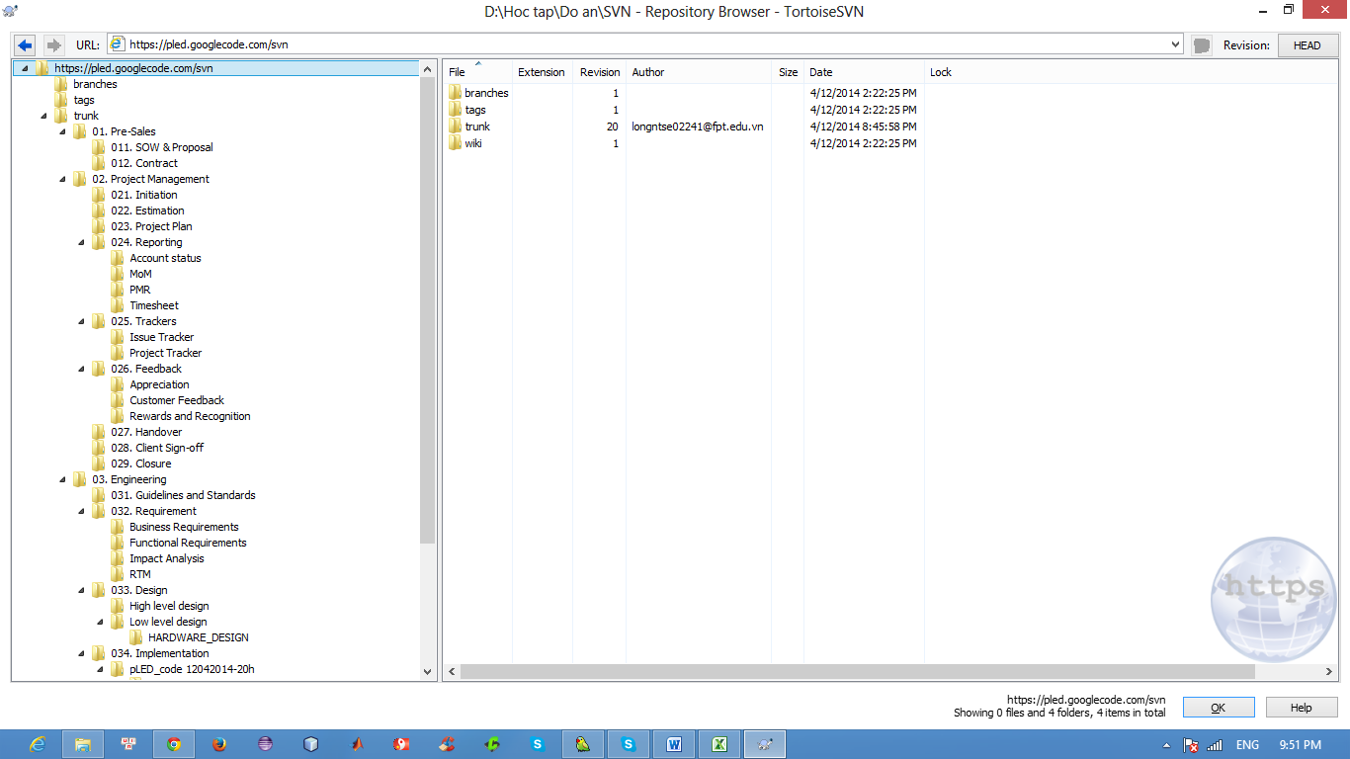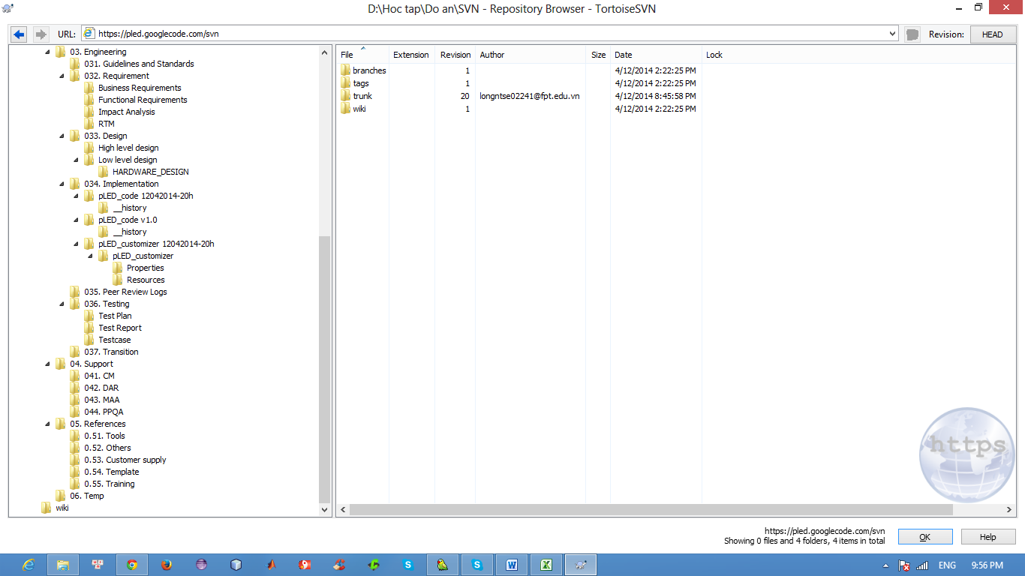
Figure 10: Configuration Management Guidelines for pLED project
Repository: https://pled.googlecode.com/svn/

5.2 Version Control
When change document must be set version following: m.n
Stage in Lifecycle | Version Number
Initial Version | 0.00
BaseLine | 1.0
Changes to Baseline Documents | 1.1
Major Enhancements | 2.0
For example: pLEDv1.0

5.3 Rules
- Document and file must be save on right folder SVN
- Version of document must be increase if it was changed
- Source code must be create baseline when release to customer and on time follow rules of project
- When commit file and document into SVN member must be write comment or message
- Bug, task, Q&A, Issue must be updated status and re-plan over due date daily

Communication and meeting
Meeting minutes 1
1/6/2014 |  | 9:00 AM |  | FU’s Library
Meeting called by | TungNT
Type of meeting | Face to face
Facilitator
Note taker | HaiDQ
Timekeeper | TungNT
Attendees | LongNT, BanDV, BachDX
Idea Research
30 mins | TungNT
Discussion | Review existed product and collect requirement to create own product.
Conclusions | Have first requirement document of project.
Action Items |  |  | Person Responsible |  | Deadline
SRS |  |  | HaiDQ |  | 1/6/2014
Table 2.8: Meeting minutes template

All Meeting minutes are noted down follow the below template and store at “trunk/02. Project Management\024. Reporting\MoM” directory of project.

CHAPTER 3: SYSTEM REQUIREMENT

User Requirement Specification

Purpose
The purpose of first part of this chapter is to specify functional, nonfunctional requirements that the product must satisfy and some use cases that user can follow to use the product easier.

Overall Description

Business Process Overview
The pLED system main purpose is for entertainment and to demonstrate the ability of the PIC microcontroller in its various features. Also to prove the skills of development team in rebuild a device base on a common known physical phenomenon.

Product Features
The pLED is a mechanic and electronic system with the main feature is a series of LEDs that rotate around a focal point. With enough rotational speed, it will display a desire image on a circle plane. The mechanism is simplification of a TV screen.

User Characteristic
User of the system is any individual who wish to decorate their home or anyone who interest in physic, electronic device. The pLED can be used for demonstrate only or can be sold as a family commodity.
Normal user: can understand the main features of the product and can use it in no more than 15 minutes.
Advanced user: have technical knowledge about the product, configure it through computer software, and change its parameters.

Functional requirement
- Display real time clock or image on rotating board with series of LEDs. The control task is responsibility of a PIC controller. The board is rotated by a DC motor.
- User can interact with the system through a RF module.
- System can be configured through computer software.

Non-functional requirement
- The display quality of clock or image on the rotation board.
- The stability of the system, power supply, running time.
- Response time of the system, after power on, response of user input.

System Requirement Specification

Purpose
The software requirement specification assures the project management stakeholders and client that the development team has really understood the business requirements documentation properly. This also provides confidence that the team will develop the functionality which has been detailed.
This part of chapter 3 is documented in such a way that it breaks the deliverables into smaller components. The information is organized in such a way that the developers will not only understand the boundaries within which they need to work, but also what functionality needs to be developed and in what order.

System purpose
Propeller LED system is use to display real time and image or text.

Scope
- A functional Propeller LED system, display accurate real time and date right after plugged in a power source.
- A propeller display with battery to show an exact time/date whenever turned on.
- A set of display mode: Analog clock, digital clock, text/image, that can be change through a dedicated remote control.
- The dedicated remote using radio wave to control.

Overall Description

System Overview
- Propeller LED system rotates then displays image, text within selection from user remote by radio control.
- Propeller LED system will count real time when system is off.

Product Features
- Display clock in real-time.
- Two to three display option:
- Digital clock
- Analog clock
- Display image or text
- User can change display mode by remote control.
- Multiple color display

User guide
- User manual: Device description
- User manual: Radio remote controller mapping

Functional specification
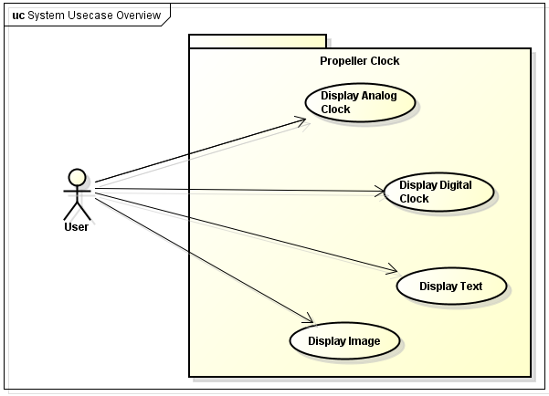
Four usecases: Display Analog Clock, Digital Clock, Text, and Image.

UC001: Display Analog Clock

Use Case Diagram
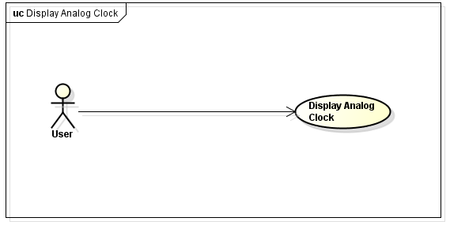

Use Case Specification

Use Case ID : | UC001
Use Case Name : | Display Analog Clock
Description : | User press button “A” on RF, then system will display analog clock.
Primary Actor: | User
Pre-Condition: | Power input 220V AC, Proper LED rotates
Post-Condition:
Flow of Events |  |  | Actor Input | System Respond
Flow of Events |  | 1 | Press button “A” on RF
Flow of Events |  | 2 |  | System display analog clock

UC002: Display Digital Clock

Use Case Diagram
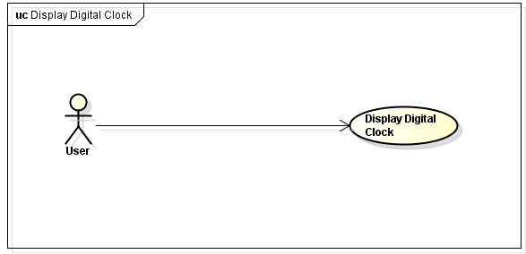

Use Case Specification
Use Case ID : | UC002
Use Case Name : | Display Digital Clock
Description : | User press button “B” on RF, then system will display digital clock.
Primary Actor: | User
Pre-Condition: | Power input 220V AC, Proper LED rotates
s  Flow of Events |  |  | Actor Input | System Respond
s  Flow of Events |  | 1 | Press button “B” on RF
s  Flow of Events |  | 2 |  | System display digital clock

Display Text

Use Case Diagram
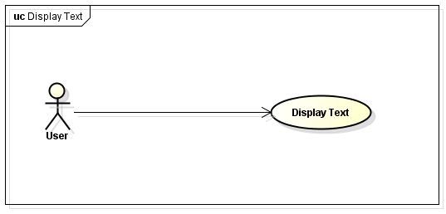

Use Case Specification
Use Case ID : | UC002
Use Case Name : | Display Text
Description : | User press button “C” on RF, then system will display text.
Primary Actor: | User
Pre-Condition: | Power input 220V AC, Proper LED rotates
Post-Condition:
Flow of Events |  |  | Actor Input | System Respond
Flow of Events |  | 1 | Press button “C” on RF
Flow of Events |  | 2 |  | System display text

Display Image

Use Case Diagram
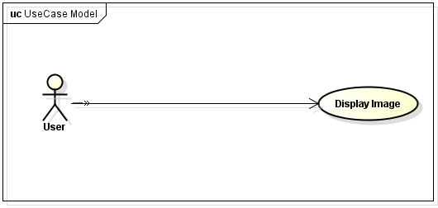

Use Case Specification
Use Case ID : | UC004
Use Case Name : | Display Image
Description : | User press button “D” on RF, then system will display image.
Primary Actor: | User
Pre-Condition: | Power input 220V AC, Proper LED rotates
Post-Condition:
Flow of Events |  |  | Actor Input | System Respond
Flow of Events |  | 1 | Press button “C” on RF
Flow of Events |  | 2 |  | System display image

Non-functional specification

Hardware
- Power supply is robust.
- Motor rotate stable.
- Real time display.

Performance Requirements
- Speed of motor at least 20 cycle per second.
- Picture display smoothly.
- Ability to run for couple of hours.
- 220V AC Power supplier.
- Run at temperature from -10⁰C to 70⁰C.
- When motor run, power up, system display within 3s.
- When use remote control, system respond after 1s.

Design Constraints
- Speed of motor enough to display picture smoothly
- Design motor supply into board with enough power
- System vibration suitable.

Usability
User can use product after 5 minutes of reading guideline.

Security
Safety for user

Protection Requirements
Avoid electric shock – proof.

Hardware/Software Requirements
- Design power supply 12V DC
- Design board easy to mechanical welding
- Design PC software to connect board via RS232
- Using RF component to remote system

Infrastructure and Tools

Hardware
No1 | Item | Why we use it?
1 | PIC16F887 | Cheaper and we already used it
2 | DS1307 | Useful to get real-time clock
3 | EEPROM | Useful to save data
4 | LED RBG | More color, more option
5 | RF | Remote control system
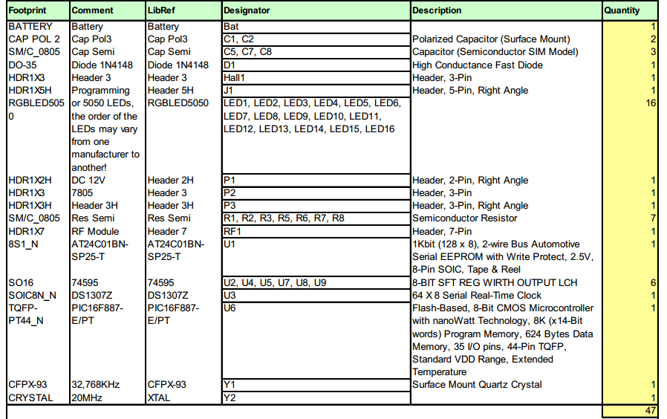

Software and tool
- CCS C 4.1 (IDE)
- ISIS Proteus (emulation)
- PICKIT2, ICD2 Programmer
- Electronic multi-meter
- DC motor
- Altium Designer 10

CHAPTER 4: SYSTEM DESIGN

ARCHITECTURE DESIGN

COMMON DESIGN
The system is controlled by interrupts. This means that tasks performed by the system are triggered by different kinds of events; an interrupt could be generated, for example, by a timer in a predefined frequency, or by a serial port controller receiving a byte.
These kinds of systems are used if event handlers need low latency, and the event handlers are short and simple. Usually, these kinds of systems run a simple task in a main loop also, but this task is not very sensitive to unexpected delays.
Sometimes the interrupt handler will add longer tasks to a queue structure. Later, after the interrupt handler has finished, these tasks are executed by the main loop. This method brings the system close to a multitasking kernel with discrete processes.

Block Diagram: Hardware Interface
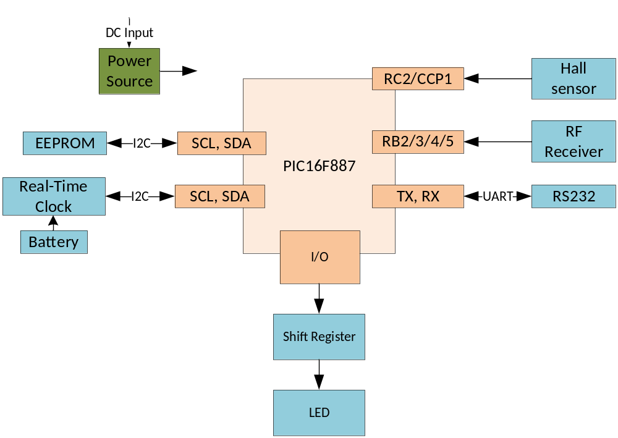
Figure 4.1: System Block Diagram

User Interface
Pic RF, pic propeller

MECHANICAL DESIGN
The motor performance is very important in circuit design. The electrics motors directly affect its speed and pushing capability.
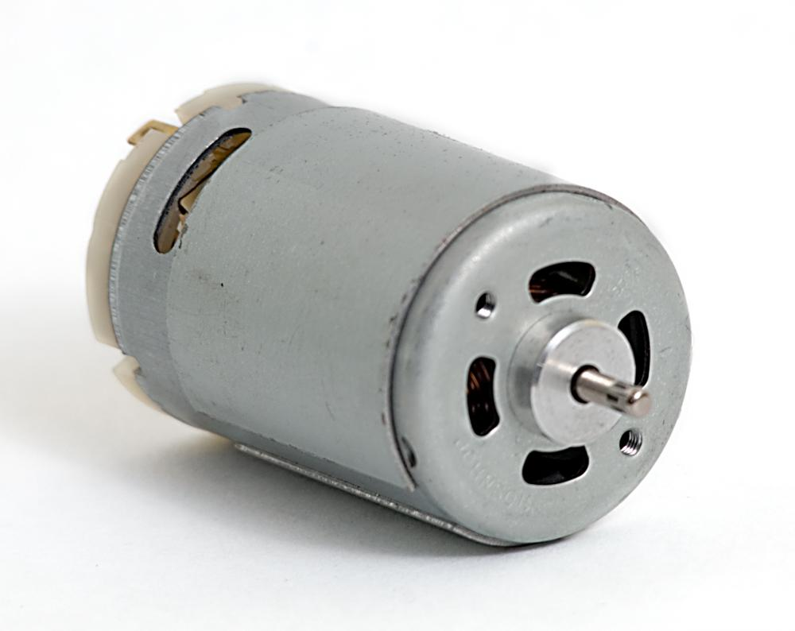
Repeated scanning of the display is necessary for continuous vision of image. This task is achieved using continuous circular rotation of the whole circuit assembly. Therefore a DC motor has used as the prime mover.

Figure 4.9: DC Motor

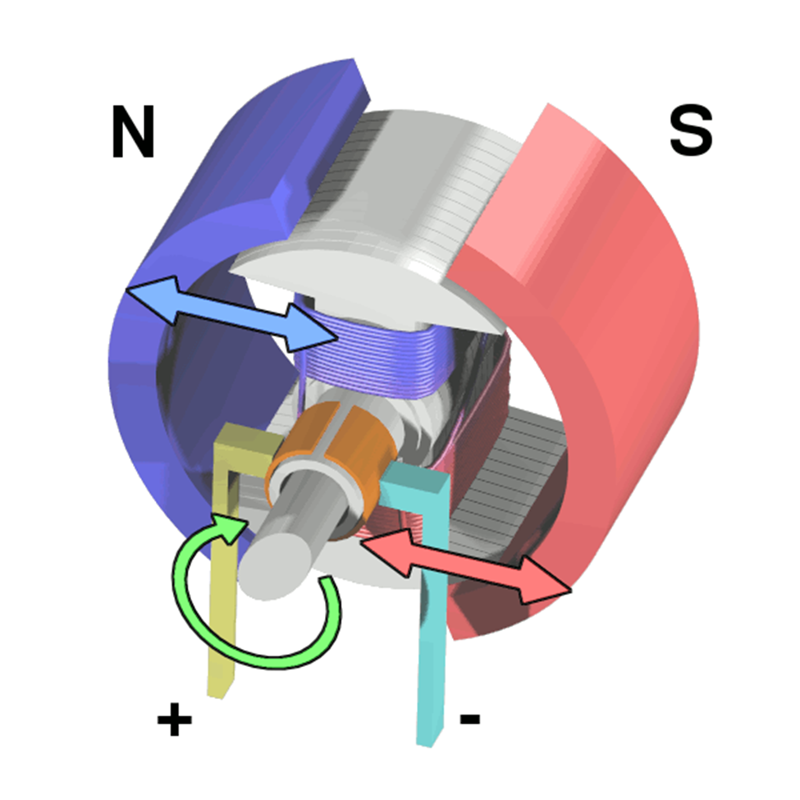

Figure 4.10: DC Motor Component
Workings of a brushed electric motor with a two-pole rotor (armature) and permanent magnet stator. "N" and "S" designate polarities on the inside faces of the magnets; the outside faces have opposite polarities. The + and - signs show where the DC current is applied to the commutator which supplies current to the armature coils.
DC motors looks quite simple. When applying a voltage to both terminals, it will spin. DC motors are non-polarized motors. Which means when changing the voltage direction, the motor will rotate in both directions, forward and backward. DC motors are rated from about 5V-12V. The larger motors are often 24V or more. But for the purpose of this project, it is necessary to use 5V-12V range motor. Voltage is directly related to torque of the motor. When increasing the supply voltage, the higher torque will be produce. And the more current supplied, the higher rpm (revolutions per minute) will be produce. Most of DC motors has low torque and high rpm. In this project, we use DC motor 5V-2A 1800rpm.

Design motor commutates
Prepare: Motor, Rolling-element bearing, Nut & bolt, Soft plastics pipe, Bronze wire, Spring.
 | 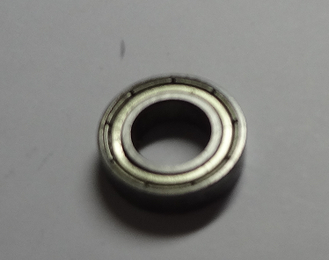
- Motor | - Rolling-element bearing
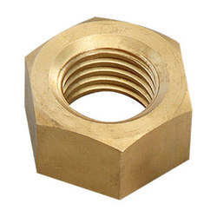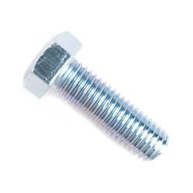 | 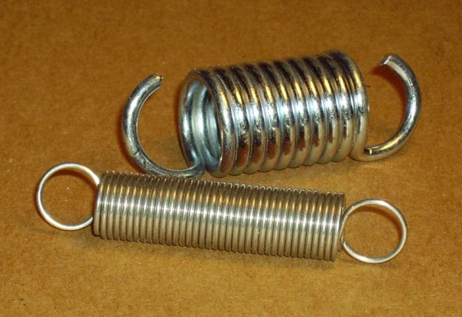
- Nut and bolt | - Spring
Figure 4.11: Rotation’s components

Execute:
Hold rolling-element bearing into cylinder following this picture
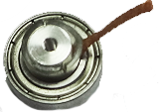
Bonze wire

rolling-element bearing ( Vcc )

soft plastics pipe

cylinder ( Ground )
Figure 4.12: Assembly Rotation’s components
Add spring around rolling-element bearing. We have product:
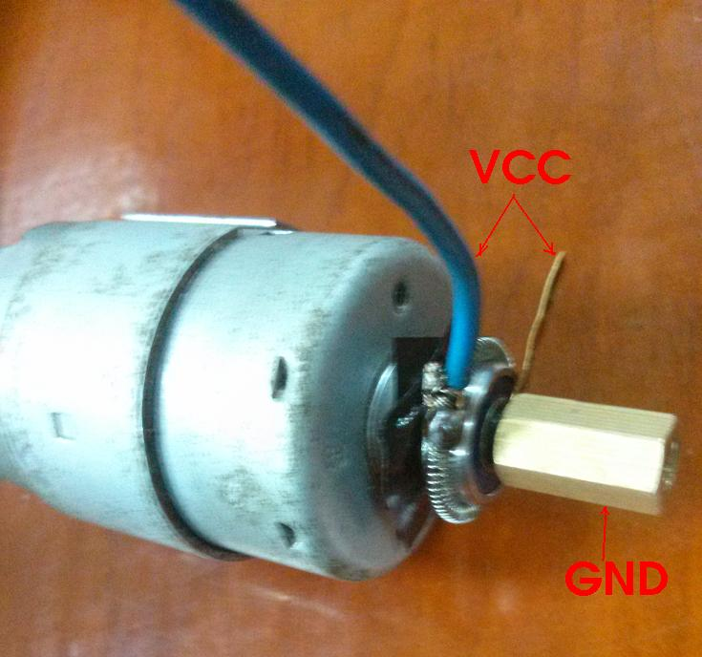
Figure 4.13: Completed Motor base

PROPELLER DESIGN

Schematic
- Power Source 12V DC input and 5V DC output. Supply current to the whole propeller:
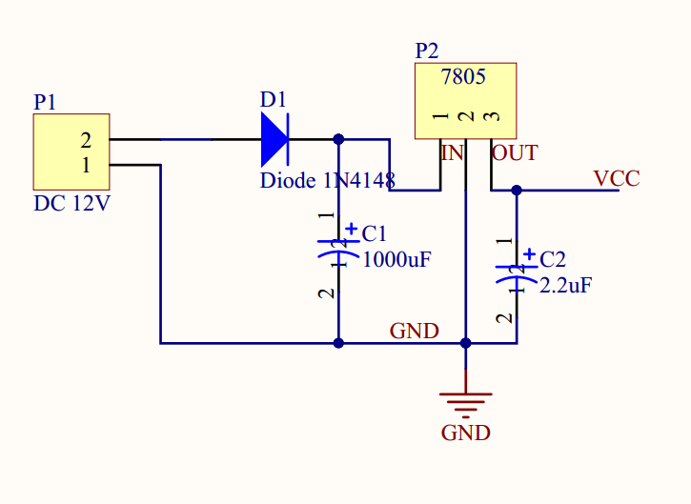
- ICSP - programming Micro Controller:
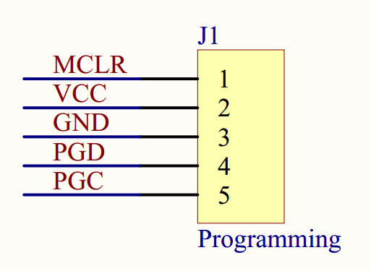

- Hall sensor - detect magnetic signal from magnet:
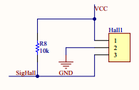
- RS232 - set time for Real-Time clock:
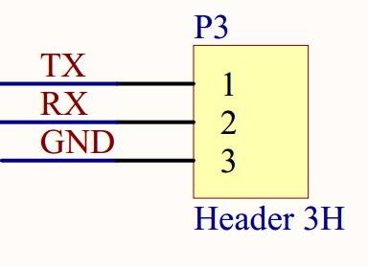
- RF receiver - receive signal from remote:
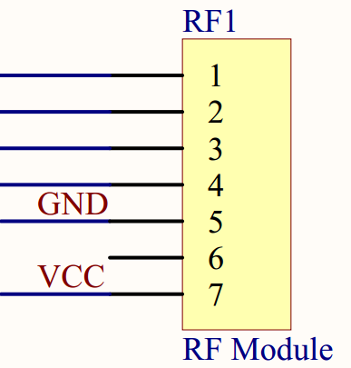
- EEPROM and Real-Time Clock:
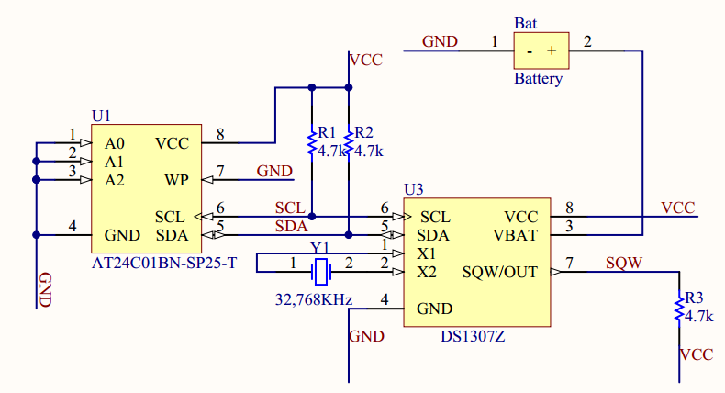
- Micro Controller:
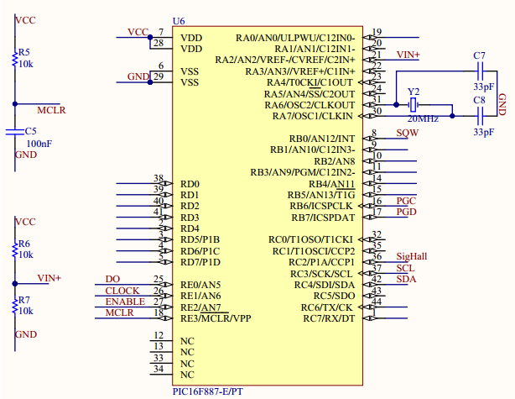

- Shift Register and LED:
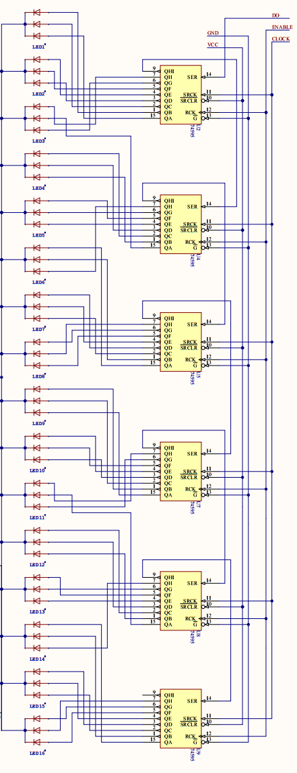
- The whole system:
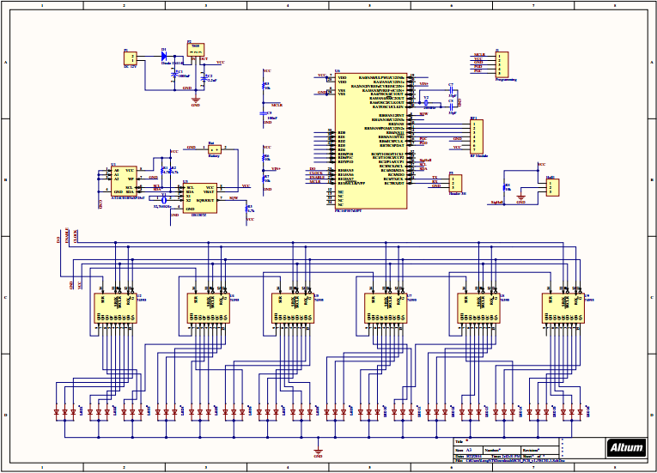

Printed Circuit Board
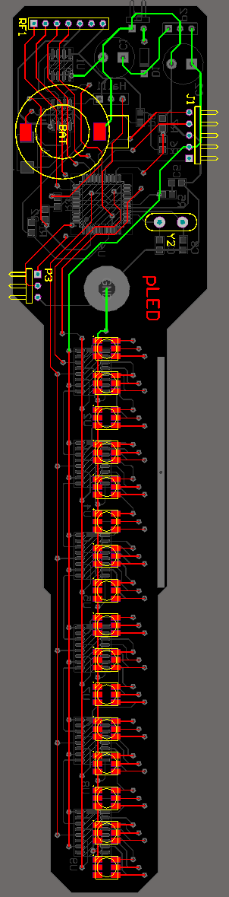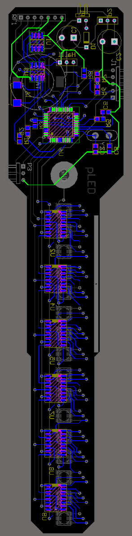

FIRMWARE DESIGN
When system starts, Micro Controller will initiate variables, includes time. Then the main program will go into a while loop, where it uses 2 interrupt for displaying:
- The first interrupt from Hall sensor to calculate the period of propeller. That period will be divided by 60, the result is the duration of light time of one NODE.
- The second one is from Timer0 of Micro Controller. This interrupt will be generated exactly after every single NODE’ duration .
LEDs are controlled by Shift Registers. Before being shift to Shift Registers, data will be processed by a special function. This function will be triggered by interrupt signal from Timer0.
System uses RF module to change display mode. There are four output pins from RF module. They are connected to Micro Controller through port B. When system receives signal from any output pins of RF module, the main program will change the value of “mode” variable, hence the display mode will be changed.

CHAPTER 5: TEST

INTRODUCTION

Purposes
This document includes test plan and test codes for the project, explanations for purpose of each test and in-progress test report. Source files will be included at the end of the document.

System Overview
The system includes a dual-layer circuit board attached to a custom DC motor and a Radio wave controller. Using 2 separate power sources operate at 220v.

TEST PLAN

Scope of Testing
The test procedure with be split into 5 part:
- Electrical connection on circuit board.
- IC components functionality
- Motor base's stability
- Circuit board's soldering
- Firmware Operation

Plan of test

Type of test | Start date | Duration | Tester | Note
Unit testing | 03/10/2014 | 5 days | HaiDQ, LongNT | After check board circuit
Functional testing | 03/15/2014 | 4 days | TungNT, BachDX
Integration testing | 03/19/2014 | 3 days | TungNT, BachDX
System testing | 04/06/2014 | 4 days | TungNT, BachDX
Acceptance testing | 04/10/2014 | 4 days | TungNT, BachDX
Usability testing | 03/10/2014 | 2 days | BanDV
Security testing | 02/20/2014 | Until Delivery product | BanDV

Requirements for Testing

Test Items
- Voltmeter
- Microcontroller Debugger
- Windows laptop
- Human

Acceptance Test Criteria
- Successfully operate in 30 minutes without any harm to audiences.
- Receive and response user’s input in less than 200ms
- Display correct real-time after power up.
- The system is robust and solid.

Testing Risks
- SMD components are too small to be tested.
- Conflict between hardware and software.
- Do not have much experience about electronic and hardware.
- Some components are made in china do not have datasheet.

Test Strategies
Bottom-Up Testing: Test the modules at the lower levels in the hierarchy, and then working up the hierarchy of modules until the final module is tested. This type of testing is appropriate for object-oriented systems in that individual objects may be tested using their own test drivers. They are then integrated and the object collection is tested.

Test Policies
- To effectively and efficiently provide timely, accurate, and useful quality risk management information.
- Test base on schematic and datasheet
- Quality risks are identified, and risk items are assessed to determine their level of risk. The level of risk determines test effort and test sequencing. Test results are reported in terms of mitigated and unmitigated risks.
- Test process:
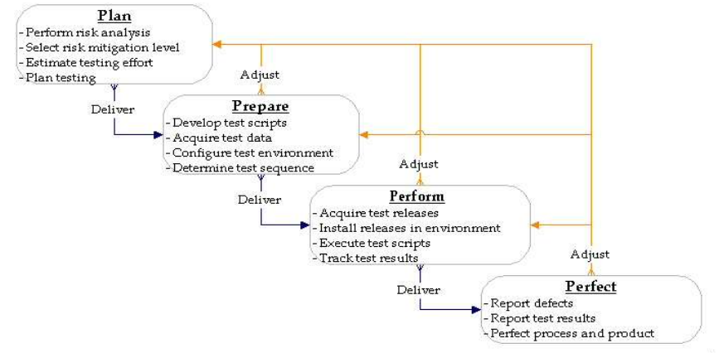

Test Model
- V model:

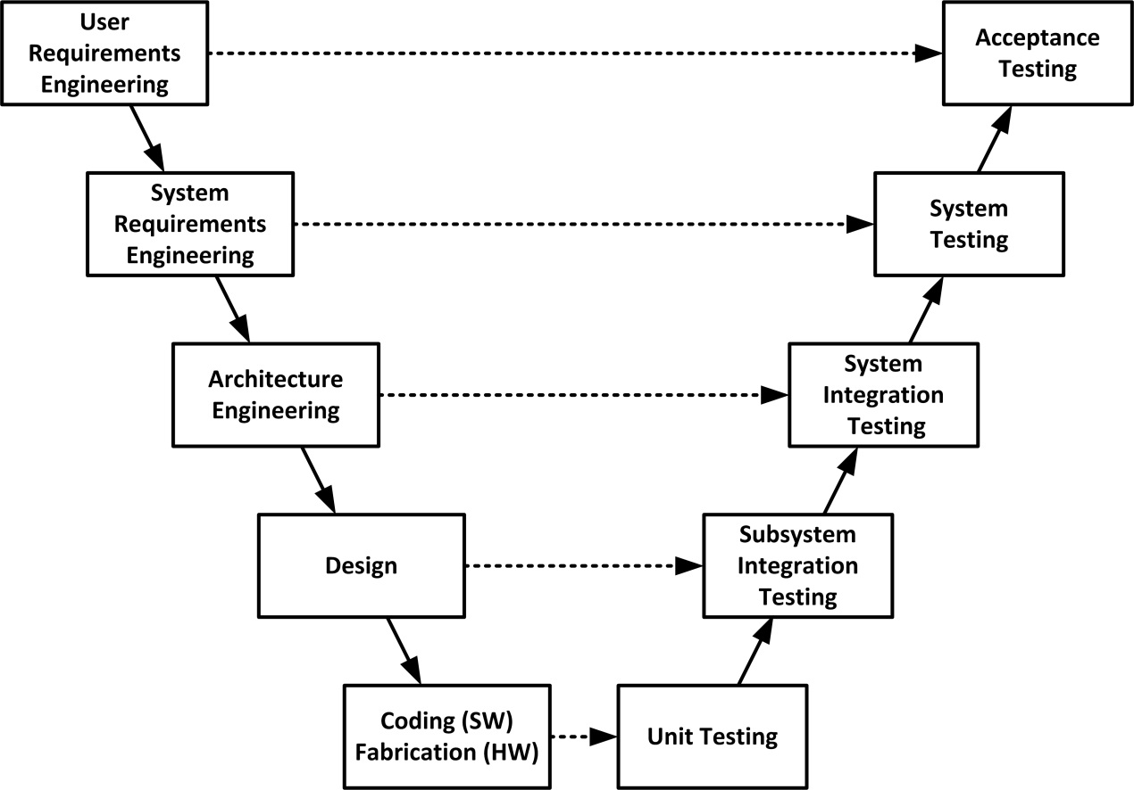

Types of Testing
- Unit testing.
- Functional testing.
- Integration testing.
- System testing.
- Acceptance testing.
- Usability testing.
- Security testing.

Test Stages
- Unit Testing: Individual components are tested to ensure that they operate correctly. Each component is tested independently without other system components.
- Module Testing: This involves the testing of independent components such as procedures and functions. A module encapsulates related components so it can be tested without other system modules.
- Subsystem Testing: This phase involves testing collections of modules which have been integrated into sub-systems. Sub-systems may be independently designed. The most common problems which arise in large software systems are sub-system interface mismatches. The sub-system test process should therefore concentrate on the detection of interface errors by rigorously exercising the interfaces.
- System Testing: Sub systems are integrated to make up the entire system. The testing process is concerned with finding errors that result from unanticipated interactions between sub-systems and system components. It is also concerned with validating that the system meets its functional and non-functional requirements.
- Acceptance Testing: This is the final stage in the testing process before the system is accepted for operational use. The system is tested with data supplied by the system procurer rather than simulated test data. Acceptance testing may reveal errors and omissions in the system requirements definition because the real data exercises the system in different ways from the test data. It may also reveal requirements problems where the system's facilities do not really meet the user's needs or the system's performance is not acceptable.

Tools/Environments
- Digital Multimeter: DT9205 A+ and VC9803A+
- Pickit 2
- Laptop
- CCS 5.015
- ICD 2 LE
- Three supplies power : 12V-1A , 5V-1A , 12V-2A

Resources
Worker/Doer | Specific Responsibilities/Comments
Test Leader | - Manage Test resource and assign test tasks.  - Create Test Plan.  - Create Test Case.  - Create Test Report.
Project Manager | - Responsible for Project schedules and the overall success of the project.  - Review Test Plan and manage test report from Test leader.  - Test some cases and scenarios.
Test Member | Execute unit testing

Deliverable

No | Deliverables | Delivered Date | Delivered by
1 | Test Plan | 03/03/2014 | Test Leader
2 | Test Case | 03/05/2014 | Test Leader
3 | Test Case Review | 03/06/2014 | Test Leader + Project Manager
4 | Test Case (Data Set) | 03/07/2014 | Test Leader
5 | Defect log | 03/18/2014 | All member
6 | Final Test Summary reports | 03/18/2014 | Project manager

TEST CASES

Circuit board connection

Dual colors led v1.0

Before Solder
TestCase ID | Item Check | Description | Expectation | Status | Person Test | Test Date | Note
Dual-001 | Hall | Hall has 3 PINs : VCC, GND, Output  1.Connect VCC hall with anode of supply power DC 3V  2.Connect GND hall with cathode of supply power DC 3V  3.Connect Output hall with anode of Led  4.Use magnet near hall | Led ON | OK | BachDX | 3/8/2014
Dual-002 | RF Module | RF has 7 PINs: 4 PIN data, VCC, GND  Connect RF with board, using code to check RF is available | 4 function are available | OK | BachDX | 3/8/2014
Dual-003 | EEPROM | Check PIN available | 8 PINs are intact | OK | BachDX | 3/8/2014
Dual-004 | PIC 16F887 | Check PIN available | 44 PINs are intact | OK | BachDX | 3/8/2014
Dual-005 | LED RBG | Connect anode and cathode of Led with supply power DC 3V | Led Blue, Green, Red ON | OK | BachDX | 3/8/2014
Dual-006 | DS 1307 | Check PIN available | 8 PINs are intact | OK | BachDX | 3/8/2014
Dual-007 | ISCP | Check PIN available | 4 PIN intact | OK | BachDX | 3/8/2014

After solder
TestCase ID | Item Check | Description | Expectation | Status | Person Test | Test Date | Note
Dual-008 | Hall | Check communication circuit correct with circuit principle | Connect | OK | TungNT | 3/14/2014
Dual-009 | RF Module | Check communication circuit correct with circuit principle | Connect | OK | TungNT | 3/14/2014
Dual-010 | EEPROM | Check communication circuit correct with circuit principle | Connect | NG | TungNT | 3/14/2014 | Drop
Dual-011 | PIC 16F887 | Check communication circuit correct with circuit principle | Connect | OK | TungNT | 3/14/2014
Dual-012 | LED Dual | Check communication circuit correct with circuit principle | Connect | NG | TungNT | 3/14/2014 | 11/16
Dual-013 | DS 1307 | Check communication circuit correct with circuit principle | Connect | NG | TungNT | 3/14/2014 | Drop
Dual-014 | RS232 | Check communication circuit correct with circuit principle | Connect | OK | TungNT | 3/14/2014
Dual-015 | ISCP | Check communication circuit correct with circuit principle | Connect | OK | TungNT | 3/14/2014

After programing
TestCase ID | Item Check | Description | Expectation | Status | Person Test | Test Date | Note
Dual-016 | Hall | Check it using code test | Action | OK | LongNT | 3/15/2014
Dual-017 | RF Module | Check it using code test | Action | OK | TungNT | 3/16/2014
Dual-018 | EEPROM |  |  | N/A |  |  | Fail after solder
Dual-019 | PIC 16F887 | Check it using code test | Action | OK | TungNT | 3/16/2014
Dual-020 | LED RBG |  |  | N/A |  |  | Fail after solder
Dual-021 | DS 1307 |  |  | N/A |  |  | Fail after solder
Dual-022 | RS232 | Check it using code test | Action | OK | TungNT | 3/16/2014
Dual-023 | ICSP | Check it using code test | Action | OK | TungNT | 3/16/2014

Triple colors led v1.0

Before Solder
TestCase ID | Item Check | Description | Expectation | Status | Person Test | Test Date | Note
Triple-01-001 | Hall | Hall has 3 PINs : VCC, GND, Output  1.Connect VCC hall with anode of supply power DC 3V  2.Connect GND hall with cathode of supply power DC 3V  3.Connect Output hall with anode of Led  4.Use magnet near hall | Led ON | OK | BachDX | 3/8/2014
Triple-01-002 | RF Module | RF has 7 PINs: 4 PIN data, VCC, GND  Connect RF with board, using code to check RF is available | 4 function are available | OK | BachDX | 3/8/2014
Triple-01-003 | EEPROM | Check PIN available | 8 PINs are intact | OK | BachDX | 3/8/2014
Triple-01-004 | PIC 16F887 | Check PIN available | 44 PINs are intact | OK | BachDX | 3/8/2014
Triple-01-005 | LED RBG | Connect anode and cathode of Led with supply power DC 3V | Led Blue, Green, Red ON | OK | BachDX | 3/8/2014
Triple-01-006 | DS 1307 | Check PIN available | 8 PINs are intact | OK | BachDX | 3/8/2014
Triple-01-007 | ICSP | Check PIN available | 4 PIN intact | OK | BachDX | 3/8/2014

After Solder
TestCase ID | Item Check | Description | Expectation | Status | Person Test | Test Date | Note
Triple-01-008 | Hall | Check communication circuit correct with circuit principle | Connect | OK | BanDV | 3/14/2014
Triple-01-009 | RF Module | Check communication circuit correct with circuit principle | Connect | OK | BanDV | 3/14/2014
Triple-01-010 | EEPROM | Check communication circuit correct with circuit principle | Connect | OK | BanDV | 3/14/2014
Triple-01-011 | PIC 16F887 | Check communication circuit correct with circuit principle | Connect | OK | BanDV | 3/14/2014
Triple-01-012 | LED RBG | Check communication circuit correct with circuit principle | Connect | NG | BanDV | 3/14/2014 | 10/16
Triple-01-013 | DS 1307 | Check communication circuit correct with circuit principle | Connect | OK | BanDV | 3/14/2014
Triple-01-014 | RS232 | Check communication circuit correct with circuit principle | Connect | OK | BanDV | 3/14/2014
Triple-01-015 | ICSP | Check communication circuit correct with circuit principle | Connect | OK | BanDV | 3/14/2014

After programing
TestCase ID | Item Check | Description | Expectation | Status | Person Test | Test Date | Note
Triple-01-016 | Hall | Check it using code test | Action | OK | HaiDQ | 3/14/2014
Triple-01-017 | RF Module | Check it using code test | Action | OK | HaiDQ | 3/14/2014
Triple-01-018 | EEPROM | Check it using code test | Action | NG | HaiDQ | 3/14/2014 | Not action
Triple-01-019 | PIC 16F887 | Check it using code test | Action | NG | HaiDQ | 3/14/2014 | Not action
Triple-01-020 | LED RBG |  |  | N/A
Triple-01-021 | DS 1307 | Check it using code test | Action | OK | HaiDQ | 3/14/2014
Triple-01-022 | RS232 | Check it using code test | Action | OK | HaiDQ | 3/14/2014
Triple-01-023 | Programming Connector | Check it using code test | Action | OK | HaiDQ | 3/14/2014

Triple colors led v2.0

Before Solder
TestCase ID | Item Check | Description | Expectation | Status | Person Test | Test Date | Note
Triple-02-001 | Hall | Hall has 3 PINs : VCC, GND, Output  1.Connect VCC hall with anode of supply power DC 3V  2.Connect GND hall with cathode of supply power DC 3V  3.Connect Output hall with anode of Led  4.Use magnet near hall | Led ON | OK | BachDX | 3/18/2014
Triple-02-002 | RF Module | RF has 7 PINs: 4 PIN data, VCC, GND  Connect RF with board, using code to check RF is available | 4 function are available | OK | BachDX | 3/18/2014
Triple-02-003 | EEPROM | Check PIN available | 8 PINs are intact | OK | BachDX | 3/18/2014
Triple-02-004 | PIC 16F887 | Check PIN available | 44 PINs are intact | OK | BachDX | 3/18/2014
Triple-02-005 | LED RBG | Connect anode and cathode of Led with supply power DC 3V | Led Blue, Green, Red ON | OK | BachDX | 3/18/2014
Triple-02-006 | DS 1307 | Check PIN available | 8 PINs are intact | OK | BachDX | 3/18/2014
Triple-02-007 | Programming Connector | Check PIN available | 4 PIN intact | OK | BachDX | 3/18/2014

After Solder
TestCase ID | Item Check | Description | Expectation | Status | Person Test | Test Date | Note
Triple-02-008 | Hall | Check communication circuit correct with circuit principle | Connect | OK | BachDX | 3/23/2014
Triple-02-009 | RF Module | Check communication circuit correct with circuit principle | Connect | OK | BachDX | 3/23/2014
Triple-02-010 | EEPROM | Check communication circuit correct with circuit principle | Connect | OK | BachDX | 3/23/2014
Triple-02-011 | PIC 16F887 | Check communication circuit correct with circuit principle | Connect | OK | BachDX | 3/23/2014
Triple-02-012 | LED RBG | Check communication circuit correct with circuit principle | Connect | NG | BachDX | 3/23/2014
Triple-02-013 | DS 1307 | Check communication circuit correct with circuit principle | Connect | OK | BachDX | 3/23/2014
Triple-02-014 | RS232 | Check communication circuit correct with circuit principle | Connect | OK | BachDX | 3/23/2014
Triple-02-015 | Programming Connector | Check communication circuit correct with circuit principle | Connect | OK | BachDX | 3/23/2014

After programing
TestCase ID | Item Check | Description | Expectation | Status | Person Test | Test Date | Note
Triple-02-016 | Hall | Check it using code test | Action | OK | LongNT | 3/24/2014
Triple-02-017 | RF Module | Check it using code test | Action | OK | LongNT | 3/24/2014
Triple-02-018 | EEPROM | Check it using code test | Action | OK | LongNT | 3/24/2014
Triple-02-019 | PIC 16F887 | Check it using code test | Action | OK | LongNT | 3/24/2014
Triple-02-020 | LED RBG | Check it using code test | Action | OK | LongNT | 3/24/2014
Triple-02-021 | DS 1307 | Check it using code test | Action | OK | LongNT | 3/24/2014
Triple-02-022 | RS232 | Check it using code test | Action | OK | LongNT | 3/24/2014
Triple-02-023 | Programming Connector | Check it using code test | Action | OK | LongNT | 3/24/2014

Base's stability
TestCase ID | Item Check | Description | Expectation | Status | Person Test | Test Date | Note
pLED-001 | Motor | Using supply power 5V-2A | Stable | OK | BanDV | 3/25/2014
pLED-002 | Base | Check it stable while motor running | Stable | OK | BachDX | 3/25/2014
pLED-003 | Circuit Board | Check it balance | Stable | OK | TungNT | 3/25/2014

TEST LOGS

Defect Logs
Defect Log
Defect Id | Component / Document Name | Test Case ID | Defect Description | Date Raised | Serverity | Status | Closed Date | Comments
Dual colors LED v1.0
1 | Hardware | Dual-010 | Cannot test function of EEPROM | 3/14/2014 | High | Closed | 3/17/2014 | Item dropped
2 | Hardware | Dual-012 | Cannot control LEDs | 3/14/2014 | High | Closed | 3/17/2014 | LEDs are blown out
3 | Hardware | Dual-013 | Cannot test function of Real-Time Clock (DS1307) | 3/14/2014 | High | Closed | 3/17/2014 | Item dropped
Triple colors LED v1.0
4 | Hardware | Triple-01-012 | LED's pins are not connect | 3/14/2014 | High | Closed | 3/20/2014
5 | Hardware | Triple-01-018 | EEPROM is uncontrolable | 3/14/2014 | High | Closed | 3/20/2014
6 | Hardware | Triple-01-019 | Cannot program PIC16F887 | 3/14/2014 | High | Closed | 3/20/2014
Triple colors LED v2.0
7 | Hardware | Triple-02-012 | LED's pins are not connect | 3/23/2014 | High | Fixed | 3/24/2014

Test Reports

Project Name | Propeller LED | Creator | BachDX
Project Code | pLED | Reviewer/Approver | TungNT
Document Code |  | Issue Date | April 04th 2014

No | Version of product | Pass | Fail | Untested | N/A | Number of test cases
1 | Dual colors LED v1.0 | 17 | 3 | 0 | 3 | 23
2 | Tripple colors LED v1.0 | 19 | 3 | 0 | 1 | 23
3 | Tripple colors LED v2.0 | 23 | 0 | 0 | 0 | 23

CHAPTER 6: USER’S GUIDE

USER’S GUIDE

Purpose
This part of the document is to tell user how to use the propeller LED, and some notice on using that may help improve life of product.

Function’s Description
Product has 4 functions:
- Display Analog Clock
- Display Digital Clock
- Display Text
- Display Image

Detailed Guidelines

UC001: Turn On/Off System
User use the switch to turn system on/off.

UC002: Remote System
User use Radio Frequency Transmitter to remote system follow the following picture:
Display Analog Clock
Display Digital Clock
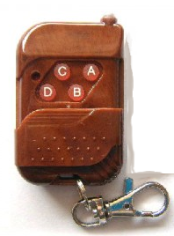
Display Text
Display Image

LESSON LEARNT
System:
- Design Schematic follow requirement
- Design printed circuit board, order board, Solder IC component
- Design hardware and calculator stable for system
- Create plan test for embedded system while waiting print printed circuit board
Management:
- Planning task, create schedule
- Working in group, brainstorming, find problem and resolve problem
- Team building, understand member
- Risk management too difficult

REFERENCE

[1] Alessandro, Propeller Clock, last modified on 31 August 2007, http://wiki.4hv.org/index.php/Propeller_clock
[2] Persistence of vision, last modified on 17 December 2013, http://en.wikipedia.org/wiki/Persistence_of_vision
[3] PCP Capstone Project, Hanoi, December 2012, FPT University

